Step-1:

* Click on the Sheet Tab and rename it as Sales Vs Profit Ratio.
* Create Calculated field(2019 Sales):

IIF(YEAR([Order Date])=2019,[Sales],0)

* Create Calculated field(2020 Sales):

IIF(YEAR([Order Date])=2020,[Sales],0)

* Drag Sales field onto the Rows Shelf
* Create a calculated field (Profit ratio)

SUM([Profit])/SUM([Sales])

* Drag Profit Ratio onto the Rows Shelf.
* Drag Order Date onto the column Shelf ,Right Click on it and Select Month.
* Add the following details in the **Marks** card:

**Color:** Drag Measure Name into colorshelf

* In the Menu Bar Change Standard into Entire View.

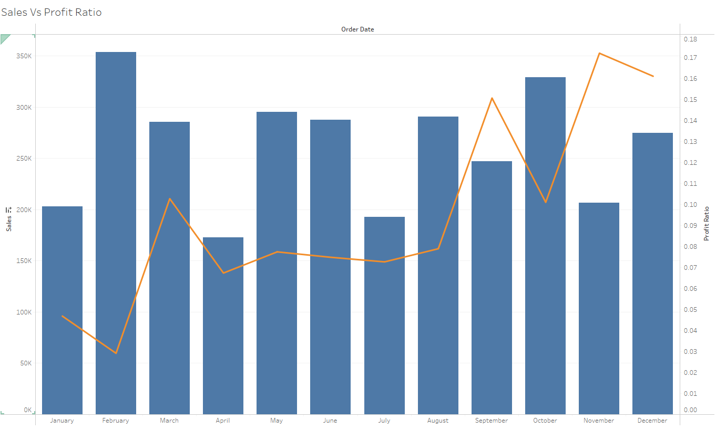

Step-2:

* Click on the Sheet Tab and rename it as lollipop Chart.
* Drag Sales field onto the Column Shelf , press control key and drag the Sales Field to Column shelf.
* Drag Sub-Category onto the Column Shelf, Right click on Sub-Category select sort and change into Descending and change the Sort by into Nested.
* Add the following details in the **Marks** card:

Sum(Sales) : Automatic into bar

Sum(Sales)2: Automatic into Circle

* In the Menu Bar Change Standard into Entire View.

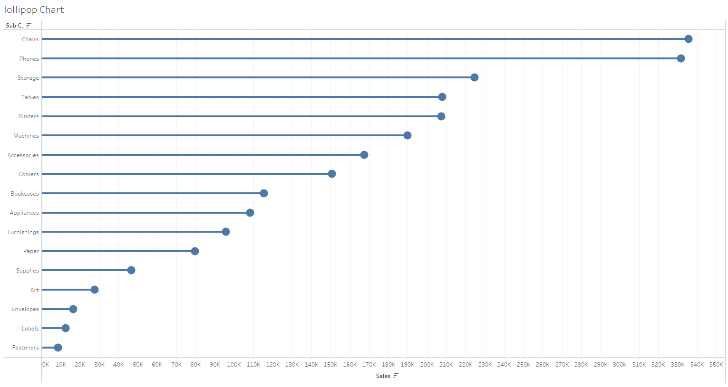

Step-3:

* Click on the Sheet Tab and rename it as Area Chart W / Total.
* Drag Sales field onto the Rows Shelf , press control key and drag the Sales Field to Rows shelf.
* Right click on Sum(sales) then change Discrete into Continuous.
* Again click on Edit Table Calculation, change Calculation Type into Running Total and SUM.
* Drag Order Date onto the column Shelf ,Right Click on it and Select Month.
* Add the following details in the **Marks** card:

Sum(Sales) : Automatic into Area

**Color :** Drag Region on Color Shelf

Sum(Sales)2: Automatic into Line

* In the Menu Bar Change Standard into Entire View.